**Establishment of BASB Automation System**

**Descriptions of the Approach**

**Objective**

This assignment requires a highly trained and experienced workforce for its successful and timely completion. The operators to be engaged in this project must have proper orientation with .NET software. In addition to that they should have adequate knowledge and experience to collect the requirements and develop the software within reasonable time. For carrying out this assignment **Saffron Corporation** would engage a team of experienced and skilled Team Leader, System Analyst and Developers/Programmers.

It is always very important to understand the objectives of a particular assignment properly for its successful and timely completion. According to the EOI (EOI Reference: **Ref No. 06.07.0000.002.05.001.16 Dated 16 October, 2016**) whereas Bangladesh Armed Service Board intends to develop an automated Web-Based integrated customized software with different modules integrated with MSSQL RDBMS. The main objective of the Web-Based Integrated Customer Software is to design a Central Web-Based software which simultaneously can be connected in central Database (DB) as well as run in local server and additionally Execute all the existing functions in efficient and cost effective way which includes the following functional features and modules:

* Personnel Module.
* Micro Credit Loan Management System Module.
* Accounts Management Module.
* Budget Management Module.
* Leave Management Module.
* Archiving Module.
* Movement Management Module
* Monthly Activities Module
* Daily Program Module
* Reports Return Management Module.

In addition to these modules (functional) the system software includes some other non-functional requirements and Technical features as per the EOI Document.

**Methodology for carrying out the activities**

**Saffron Corporation** would follow some basic principles and methods to carry out the assignment. A proposed work flow is provided below:

|  |  |  |
| --- | --- | --- |
| Sl no. | Deliverables | Methodology |
| 01. | System Requirement Specifications (SRS) | The Requirement analysis team will specify the specific functional and non-functional requirements from Stakeholders/Clients for intended software. |
| 02. | Software design and development | Software Architecture or Designer will sketch the portrait form of proposed software according to the SRS. In additionally User Interface (UI) will also be demonstrated. |
| According to the design template developers or programmers will start implementing the proposed application. For front end applications .NET or equivalent web based programming language will be used. Frameworks like MVC or CodeIgnitor will also be used. Database will also be developed using open source platform like MSSQL 2014. |
| 03. | Software testing | After executing implementation level software will be tested to fix the bugs or any kind of erroneous output to ensure the product quality control |
| 04. | Software piloting | Software would be piloted in a limited scale. After successful piloting, it will execute for full scale operation. |
| 05. | Training of End-users | Trainers in coordination with other team members will provide training to the End-users. |
| 06. | Implementation | BASB Automation System Software will be in full-fledged operation. |

**Deployment Flow-Chart for Software Development**

**Requirements & Designing**

**CODING**

**TESTING**

**ERRORS?**

YES

**Bugs/ Design Errors?**

NO

Bugs

**Deployment**

Design Error

**Software Development Life Cycle**

**Methodology: Agile Methodology**

In this method project backlog and burn-down rates can be tracked systematically.

1. SRS: information gathering on each module
2. Release management: Release of each module will mark the end of a release cycle.
3. Web Server: IIS Microsoft’s Web and Application server, secured and customizable.
4. Programming language: C#, JavaScript, Stored Procedure, ASP.Net
5. Framework: MVC 4 or Web Form
6. Microsoft’s Web Framework, very much suitable for Enterprise Solution
7. User interface: Responsive (Bootstrapping 3.0 or higher)

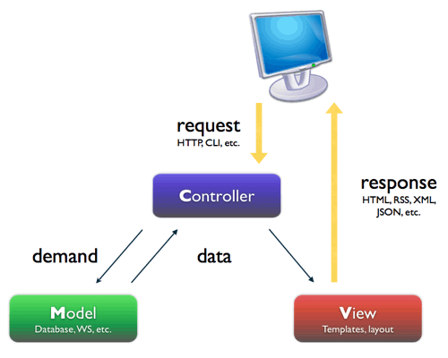

1. Database:

* SQL Server 2014 : Enterprise Grade Database with unlimited storage option

1. Reporting Tool: Crystal Report
2. Used for generating complex format report and export them as various document format and archive.
3. Web tool: ASP.Net Framework 4.0 or higher for front end developing, such AngularJs etc.
4. Layer wise tracking, error handling and caching based on requirements.

**Software Development Process:**

* In Agile Development End user or Client involvment is the key factor here as more closeley involved at the ttime of work being performed.
* In Agile software development process when problems occure in reponse of that team works together resolve them internally.
* In Agile development process weekly standup meetings are held to discuss the work breakdown structure done last day, plannning of today and implements it if necessary.
* In Agile development process task is delivered to client in small and frequently release process base to get rapid feedbace on it.

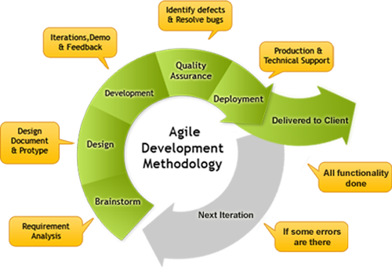

[Fig: Web Based Integrated Customized SoftwareDeployment Process]

**Software Architecture:**

* 3-Tier, Domain Driven Design which facilitates multi server system
* The client machine having web browser to display the UI part of the application also called as Presentation Layer

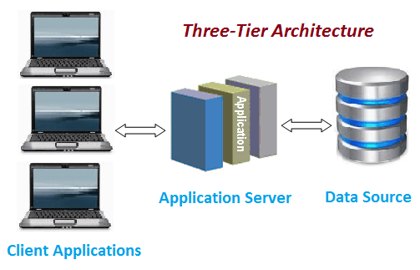

ClientHTTP request

ORACLE DB

ASP.Net/ Java/ PHP

[Fig: 3-Tier Web Based Integrated Software Architecture]

* The application server /Web server called the Application Layer contains the application logic and also acts as interface between presentation Layer and Data Layer.

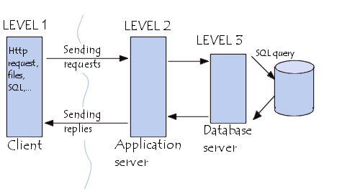

* The database Server also called as Data Layer maintains the application data.
* Test Driven Development that ensures each method works efficiently and later on regression tests do not fail.

**Hardware Architecture**

* The system will be hosted by an array of different hardware. Different servers may be used for database and applications.
* Local intranet or internet both will be supported and will be configured.
* Network designed with firewall and bandwidth controller to keep servers secured
* Backup system for high availability and fault tolerance

**System Design Process**

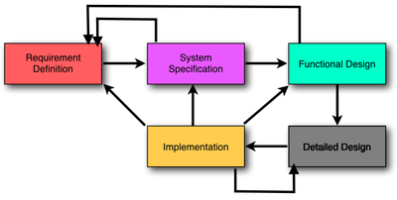

**Basic Workflow Structure**

Web Based Software (BASB)

Micro Credit Loan

Daily Program

Movement

Mgmt.

Leave Mgmt.

Budget

Accounts

Personnel

Monthly Activity

Reports Return Mgmt. System

Archiving

**Describing of the Work Plan**

The team would follow some basic principles and methods to carry out the assignment. A graphic description of proposed work flow is provided below:

|  |  |
| --- | --- |
| **Step:1** | The System Analyst would collect the requirements from the BASB Authority. |
| **Step:2** | The Team Leader and System Analyst would analyze the requirements and will develop a structure for development the software on the right way and within timeline. |
| **Step:3** | The team leader would distribute the work among the programmers and would monitor the work progress. |
| **Step:4** | The programmers would develop the project and release the Beta version of the software. |
| **Step:5** | The Team Leader would make sure that the development going on the right way with maintaining the security, restrictions and all other issues the required for complete the project. |
| **Step:6** | The Quality control unit will create a Test plan and run the Test script to testify the intended software on the basis of actual output of the product, if any bugs are identified then it is reprogrammed in the development section again. |
| After minimizing the bugs the Quality control unit runs the Acceptance testing to ensure the quality of the product. |
| **Step:7** | The Project Manager would check the deployment and release the final version of the intended software. |

The team of Developers engaged for this assignment would work under the supervision of 4X Supervisors. It would ensure quality of work. They will work following the office hours. But if the task requires they would work beyond the office hour and even on holidays to meet the deadline.

**Quality Plan work flow to outline the software**

To ensure quality of the software a ‘Quality Control Mechanism’ would be established.

System Analyst gathers the requirements

Designer outline the User Interface of software

Programmers coding to deploy the software

Quality assurance controller check software quality

Error

Yes Yes

Erroneous output Erroneous Design

No

Project Manager check final software deployment process

Release Final version of the software

**Modeling Requirements**

**Modeling USE Case Diagram for BASB Web Based Software**

. .

**User**

**Admin**

Reports Return Mgmt. System

Personnel

Micro Credit Loan

Monthly Activity

Daily Program

Archiving

Leave Mgmt.

Budget

Accounts

Movement

Mgmt.